3

INTERDEPENDENCE AND THE GAINS FROM TRADE

WHAT’S NEW IN THE SEVENTH EDITION:

There is a new In The News feature on "Economics within a Marriage."

LEARNING OBJECTIVES:

By the end of this chapter, students should understand:

- how everyone can benefit when people trade with one another.

- the meaning of absolute advantage and comparative advantage.

- how comparative advantage explains the gains from trade.

- how to apply the theory of comparative advantage to everyday life and national policy.

CONTEXT AND PURPOSE:

Chapter 3 is the third chapter in the three-chapter section that serves as the introduction of the text. Chapter 1 introduced ten fundamental principles of economics. Chapter 2 developed how economists approach problems. This chapter shows how people and countries gain from trade (which is one of the ten principles discussed in Chapter 1).
The purpose of Chapter 3 is to demonstrate how everyone can gain from trade. Trade allows people to specialize in the production of goods for which they have a comparative advantage and then trade for goods that other people produce. Because of specialization, total output rises, and through trade we are all able to share in the bounty. This is as true for countries as it is for individuals. Because everyone can gain from trade, restrictions on trade tend to reduce welfare.

KEY POINTS:

- Each person consumes goods and services produced by many other people both in the United States and around the world. Interdependence and trade are desirable because they allow everyone to enjoy a greater quantity and variety of goods and services.

- There are two ways to compare the ability of two people to produce a good. The person who can produce the good with a smaller quantity of inputs is said to have an absolute advantage in producing the good. The person who has the smaller opportunity cost of producing the good is said to have a comparative advantage. The gains from trade are based on comparative advantage, not absolute advantage.

- Trade makes everyone better off because it allows people to specialize in those activities in which they have a comparative advantage.

- The principle of comparative advantage applies to countries as well as to people. Economists use the principle of comparative advantage to advocate free trade among countries.

CHAPTER OUTLINE:

Begin by explaining that there are two basic ways that individuals can satisfy their wants. The first is to be economically self-sufficient. The second is to specialize in the production of one thing and then trade with others. With rare exceptions, individuals and nations tend to rely on specialization and trade. One way to demonstrate this is to survey the students on their future plans (doctors, lawyers, teachers, etc.). Point out that they plan to specialize and trade. Ask them why this is optimal.


I. A Parable for the Modern Economy

A. Example: two goods—meat and potatoes; and two people—a cattle rancher named Rose and a potato farmer named Frank (each of whom likes to consume both potatoes and meat).

1. The gains from trade are obvious if Frank can only grow potatoes and Rose can only raise cattle.

2. The gains from trade are also obvious if, instead, Frank can raise cattle as well as grow potatoes, but he is not as good at it and Rose can grow potatoes in addition to raising cattle, but her land is not well suited for it.

3. The gains from trade are not as clear if either Frank or Rose is better at producing both potatoes and meat.


Make sure that you write out all of the algebra involved in this example. If you leave out steps, students will not understand how these calculations are made.

B. Production Possibilities

1. Frank and Rose both work eight hours per day and can use this time to grow potatoes, raise cattle, or both.

2. Figure 1 shows the amount of time each takes to produce one ounce of either good:
Figure 1

 | Minutes Needed to Make One Ounce of: |  | Amount Produced in Eight Hours
 | Meat | Potatoes | Meat | Potatoes
Frank the farmer | 60 min./oz. | 15 min./oz. | 8/1=8 oz. | 8/0.25=32 oz.
Rose the rancher | 20 min./oz. | 10 min./oz. | 8/0.33=24 oz. | 8/0.16=48 oz.

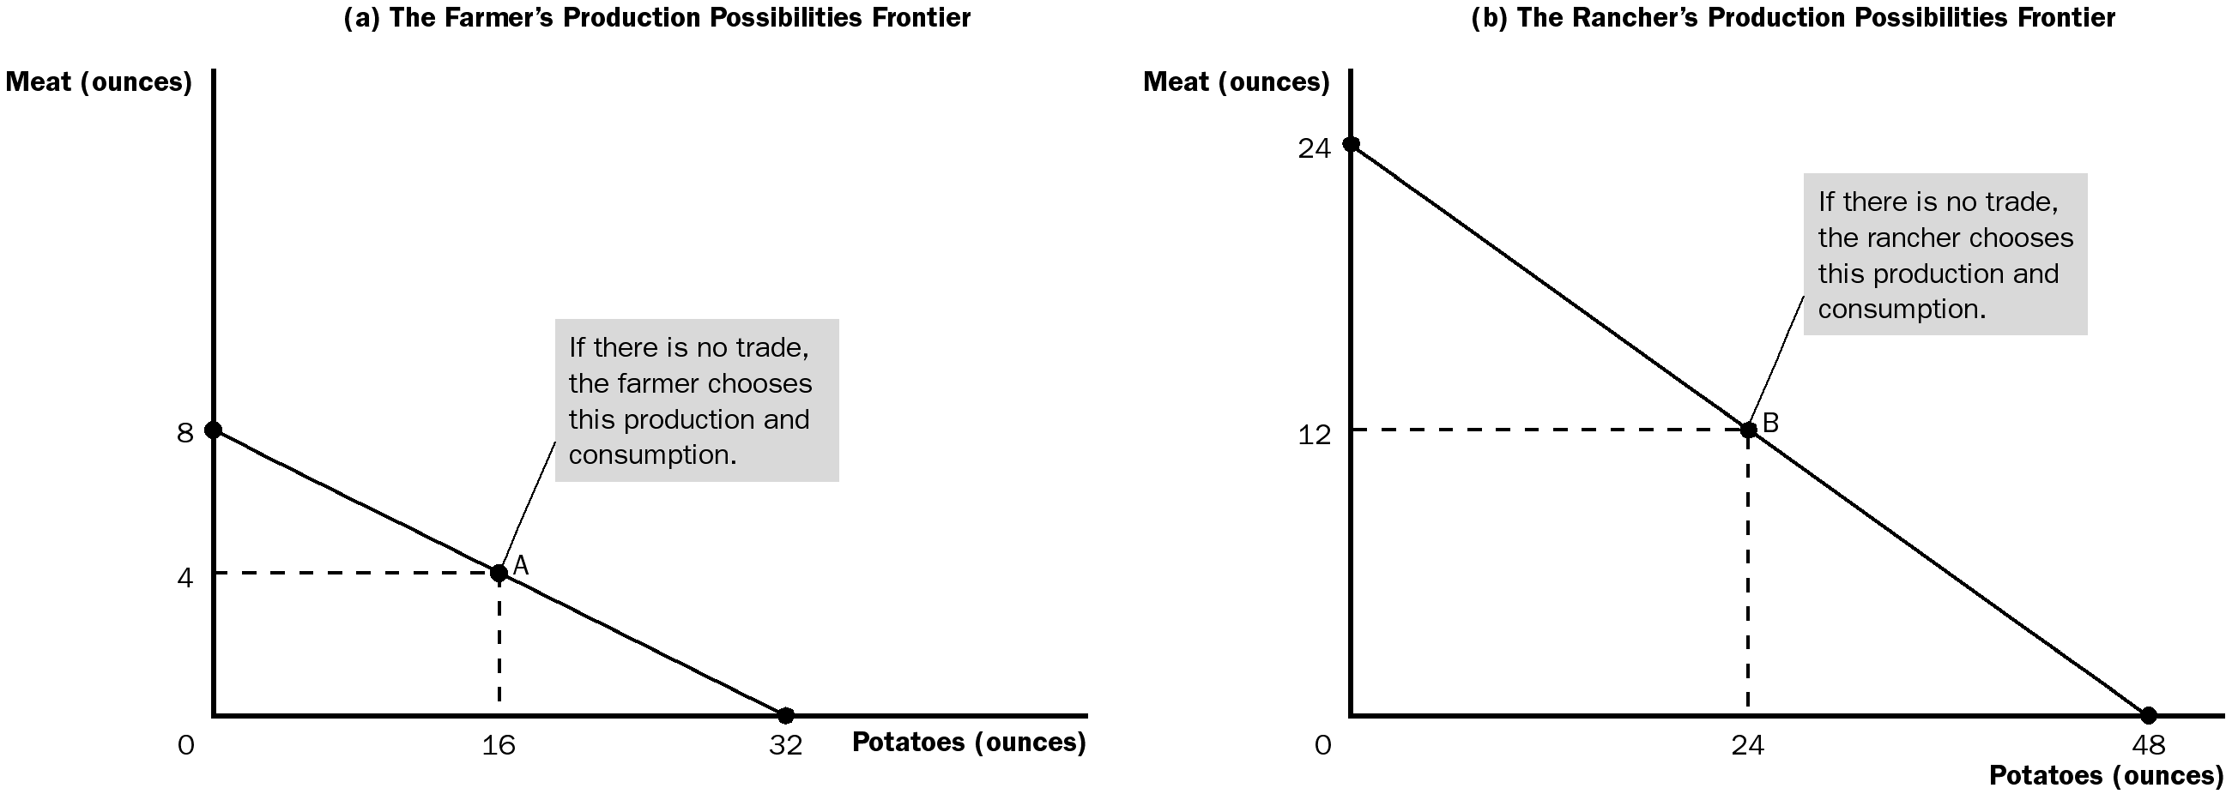

ALTERNATIVE CLASSROOM EXAMPLE:
Martha and Stewart each spend eight hours a day wallpapering and painting:

 | Hours Needed to Do One Room |  | Rooms Finished in 40 Hours
 | Paint | Wallpaper | Paint | Wallpaper
Martha | 2 hours/room | 8 hours/room | 8/2=4 rooms | 8/8=1 room
Stewart | 4 hours/room | 10 hours/room | 8/4=2 rooms | 8/10=0.8 room

3. The production possibilities frontiers can also be drawn.

a. These production possibilities frontiers are drawn linearly instead of being bowed out. This assumes that Frank's and Rose's technology for producing meat and potatoes allows them to switch between producing one good and the other at a constant rate.

b. As we saw in Chapter 2, these production possibilities frontiers represent the principles of trade-offs and opportunity costs.
It is important to take the time to explain how to calculate the x- and y-intercepts. Point out that Frank could produce 8 ounces of meat if all of his time is spent on meat or 32 ounces of potatoes if all of his time is spent on potatoes.

4. We will assume that Frank and Rose divide their time equally between raising cattle and growing potatoes.

a. Frank produces (and consumes) at point A—16 ounces of potatoes and 4 ounces of meat.

b. Rose produces (and consumes) at point B—24 ounces of potatoes and 12 ounces of meat.

You should emphasize that these production possibilities frontiers represent the farmer’s and the rancher’s consumption possibilities because we are assuming that there is no trade.

C. Specialization and Trade

1. Suppose Rose suggests that Frank specialize in the production of potatoes and then trade with her for meat.

a. Rose will spend six hours a day producing meat (18 ounces) and two hours a week growing potatoes (12 ounces).

b. Frank will spend eight hours a day growing potatoes (32 ounces).

c. Rose will trade 5 ounces of meat for 15 ounces of potatoes.

Students will ask how this “price” is determined. Explain the range of prices that each participant would be willing to accept.

2. End results:

a. Rose produces 18 ounces of meat and trades 5 ounces, leaving her with 13 ounces of meat. She also grows 12 ounces of potatoes and receives 15 ounces in the trade, leaving her with 27 ounces of potatoes.

b. Frank produces 32 ounces of potatoes and trades 15 ounces, leaving him with 17 ounces. He also receives 5 ounces of meat in the trade with Rose.

3. In both cases, they are able to consume quantities of potatoes and meat after the trade that they could not reach before the trade.

Prove to your students that it would take each of them more than eight hours to produce these quantities on their own.

Figure 2

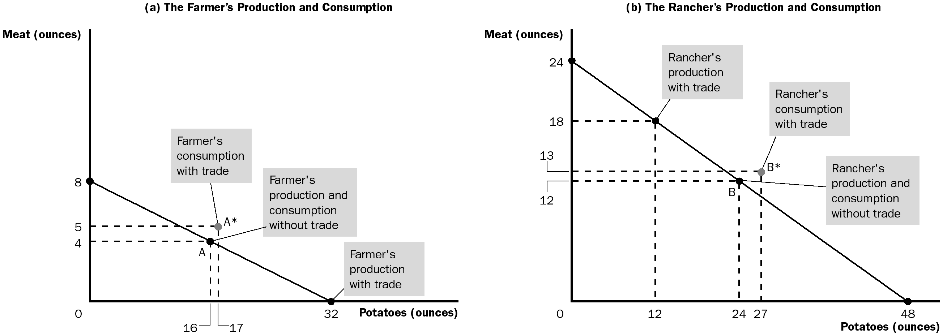

II. Comparative Advantage: The Driving Force of Specialization

A. Absolute Advantage

1. Definition of absolute advantage: the ability to produce a good using fewer inputs than another producer does.

2. Rose has an absolute advantage in the production of both potatoes and meat.

B. Opportunity Cost and Comparative Advantage

1. Definition of opportunity cost: whatever must be given up to obtain some item.

Table 1

a. For Rose, it takes ten minutes to produce one ounce of potatoes. Those same ten minutes could be used to produce one-half ounce of meat. Thus, the opportunity cost of producing an ounce of potatoes is one-half ounce of meat.

b. For Frank, it takes 15 minutes to produce one ounce of potatoes. Those same 15 minutes could be used to produce one-fourth ounce of meat. Therefore, the opportunity cost of producing one ounce of potatoes is one-fourth ounce of meat.

c. The opportunity cost of producing one ounce of meat is the inverse of the opportunity cost of producing one ounce of potatoes.

Your students may have a hard time comprehending this. Make sure that you go through these calculations several times and write out every step on the board.

2. Definition of comparative advantage: the ability to produce a good at a lower opportunity cost than another producer.

a. Frank has a lower opportunity cost of producing potatoes and therefore has a comparative advantage in the production of potatoes.

b. Rose has a lower opportunity cost of producing meat and therefore has a comparative advantage in the production of meat.

3. Because the opportunity cost of producing one good is the inverse of the opportunity cost of producing the other, it is impossible for a person to have a comparative advantage in the production of both goods.

C. Comparative Advantage and Trade

1. When specialization in a good occurs (assuming there is a comparative advantage), total output will grow.

2. As long as the opportunity cost of producing the goods differs across the two individuals, both can gain from specialization and trade.

a. Frank buys 5 ounces of meat with 15 ounces of potatoes. This implies that the price of each ounce of meat is three ounces of potatoes, which is lower than Frank's opportunity cost of four ounces of potatoes. Trade is beneficial to Frank.

b. Rose buys 15 ounces of potatoes for 5 ounces of meat. The price of each ounce of potatoes is one-third ounce of meat. This is lower than Rose's opportunity cost of one-half ounce of meat. Trade also benefits Rose.

D. The Price of the Trade

1. For both parties to gain from trade, the price at which they trade must lie between the opportunity costs.

2. In our example, Frank and Rose must trade at the rate of between 2 and 4 ounces of potatoes for each of meat.

Activity 1—Creating Comparative Advantage Examples

Type: In-Class Assignment
Topics: Specialization, interdependence, self-interest, comparative advantage
Materials needed: 3-5 candy bars (or similar items to use as prizes)
Time: 15 minutes (first day), depends on number of groups (second day)
Class limitations: works in any size class

Purpose
This assignment allows students to further explore comparative advantage.

Instructions
Divide the class into groups of three or four to write a comparative advantage problem of their own. Tell them to make creative, humorous, yet plausible examples.

Give the students fifteen minutes to work on creating their examples at the end of class.

Instruct them to bring a neatly written copy of their examples for the next class when each group will present its example to the rest of the class. Students should include tables and figures similar to those used in class.

Let the students vote on which group has the best example and award a small prize to the group’s members.

Make the examples available to all of the students in the class to use as practice problems for the exam.

E. FYI: The Legacy of Adam Smith and David Ricardo

1. In Adam Smith's 1776 book An Inquiry into the Nature and Causes of the Wealth of Nations, he writes of the ability of producers to benefit through specialization and trade.

2. In David Ricardo's 1817 book Principles of Political Economy and Taxation, Ricardo develops the theory of comparative advantage and argues against restrictions on free trade.

3. The benefits of free trade are an issue that is generally agreed upon by most economists, and the theories and arguments developed by these two individuals 200 years ago are still used today.

IV. Applications of Comparative Advantage

A. Should Tom Brady Mow His Own Lawn?

1. Imagine that Brady can mow his lawn faster than anyone else can.

2. This implies that he has an absolute advantage.

3. Suppose that it takes him two hours to mow his lawn. In that same two hours, he could film a commercial for which he would earn $20,000. This means that the opportunity cost of mowing his lawn is $20,000.

4. It is likely that someone else would have a lower opportunity cost of mowing Brady’s lawn; this individual would have a comparative advantage.

5. Both he and the person hired will be better off as long as he pays the individual more than the individual's opportunity cost and less than $20,000.

B. Should the United States Trade with Other Countries?

1. Just as individuals can benefit from specialization and trade, so can the populations of different countries.

2. Definition of imports: goods produced abroad and sold domestically.

3. Definition of exports: goods produced domestically and sold abroad.

4. The principle of comparative advantage suggests that each good should be produced by the country with a comparative advantage in producing that good (smaller opportunity cost).

5. Through specialization and trade, countries can have more of all goods to consume.

6. Trade issues among nations are more complex. Some individuals can be made worse off even when the country as a whole is made better off.

C. In the News: Economics within a Marriage

1. The principles of comparative advantage and gains from specialization and trade even apply to housework.

2. This article from Slate describes the division of housework between the author and her husband, even though she has the absolute advantage in doing it all..

To help convince students that importing goods is not harmful to a country, ask the students to devise a way to produce coffee domestically. Point out that it is possible to grow coffee beans in the United States in enclosed nurseries, but the opportunity cost of the resources used would be significant.

Discuss how differences in resource endowments can be significant factors in determining opportunity cost and comparative advantage. Such differences include climate, soil composition, education and training of the labor force, capital stock, and infrastructure.

SOLUTIONS TO TEXT PROBLEMS:

Quick Quizzes

1. Figure 1 shows Robinson Crusoe’s production possibilities frontier for gathering coconuts and catching fish. If Crusoe lives by himself, this frontier limits his consumption of coconuts and fish, but if he can trade with natives on the island, he will possibly be able to consume at a point outside his production possibilities frontier.

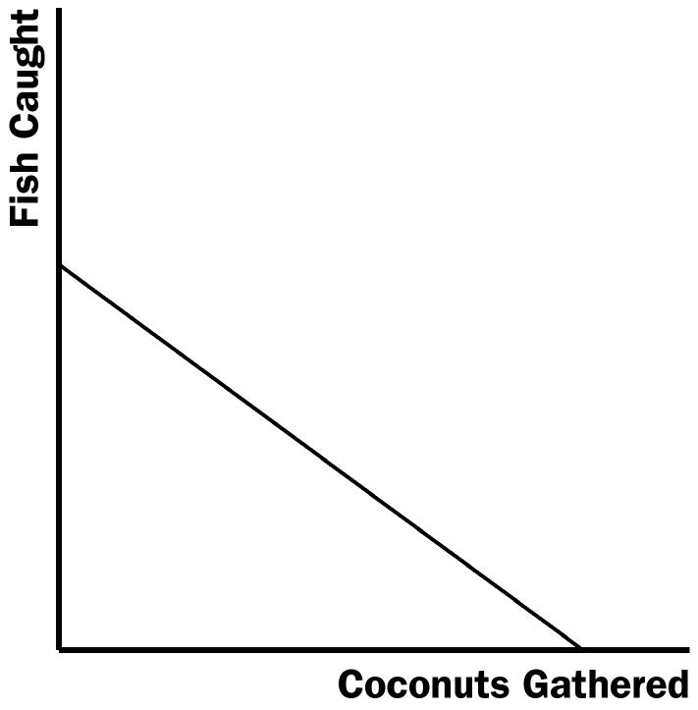

Figure 1

2. Crusoe’s opportunity cost of catching one fish is 10 coconuts, since he can gather 10 coconuts in the same amount of time it takes to catch one fish. Friday’s opportunity cost of catching one fish is 15 coconuts, since he can gather 30 coconuts in the same amount of time it takes to catch two fish. Friday has an absolute advantage in catching fish, since he can catch two per hour, while Crusoe can catch only one per hour. But Crusoe has a comparative advantage in catching fish, since his opportunity cost of catching a fish is less than Friday’s.

3. If the world’s fastest typist happens to be trained in brain surgery, she should hire a secretary because the secretary will give up less for each hour spent typing. Although the brain surgeon has an absolute advantage in typing, the secretary has a comparative advantage in typing because the secretary would have a lower opportunity cost of typing.

Questions for Review

1. The production possibilities frontier will be linear if the opportunity cost of producing a good is constant no matter how much of that good is produced. This will be most likely if the good is not produced using specialized inputs.

2. Absolute advantage reflects a comparison of the productivity of one person, firm, or nation to that of another, while comparative advantage is based on the relative opportunity costs of the persons, firms, or nations. While a person, firm, or nation may have an absolute advantage in the production of every good, they cannot have a comparative advantage in the production of every good.

3. Many examples are possible. Suppose, for example, that Roger can prepare a meal of hot dogs and macaroni in just 10 minutes, while it takes Anita 20 minutes. Also suppose that Roger can do all the laundry in 3 hours, while it takes Anita 4 hours. Roger has an absolute advantage in both cooking and doing the laundry, but Anita has a comparative advantage in doing the laundry. For Anita, the opportunity cost of doing the laundry is 12 meals; for Roger, it is 18 meals.

4. Comparative advantage is more important for trade than absolute advantage. In the example in Problem 3, Anita and Roger will complete their chores more quickly if Anita does at least some of the laundry and Roger cooks the meals for both, because Anita has a comparative advantage in doing the laundry, while Roger has a comparative advantage in cooking.

5. In order for trade to benefit both parties, the price for the trade must lie between the parties’ opportunity costs.

6. Economists oppose policies that restrict trade among nations because trade allows all countries to achieve greater prosperity by allowing them to receive the gains from comparative advantage. Restrictions on trade can hurt all countries.

Quick Check Multiple Choice
1. d
2. b
3. a
4. d
5. b
6. d

Problems and Applications

1. a. See Figure 2. If Maria spends all 5 hours studying economics, she can read 100 pages, so that is the vertical intercept of the production possibilities frontier. If she spends all 5 hours studying sociology, she can read 250 pages, so that is the horizontal intercept. The opportunity costs are constant, so the production possibilities frontier is a straight line.

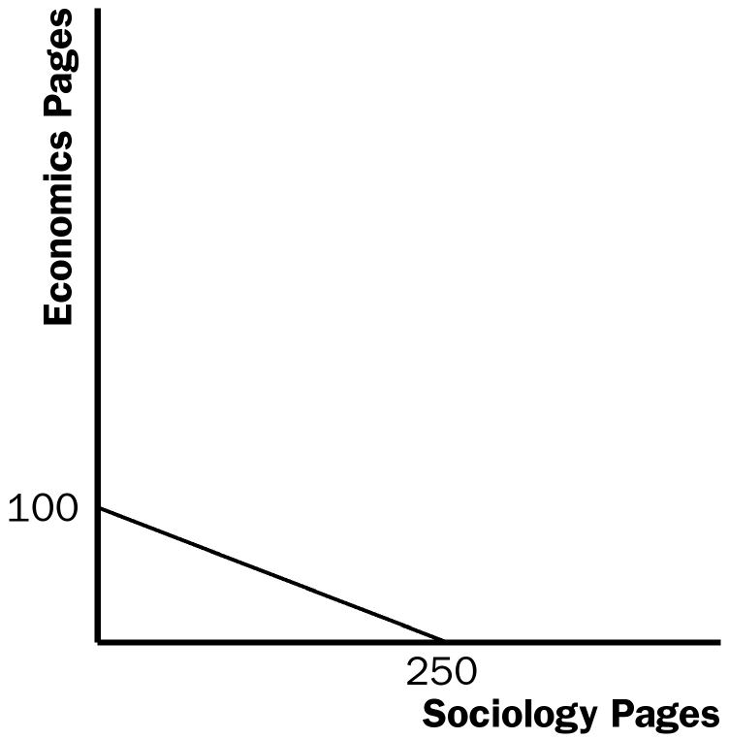

Figure 2

b. It takes Maria 2 hours to read 100 pages of sociology. In that time, she could read 40 pages of economics. So the opportunity cost of 100 pages of sociology is 40 pages of economics.

2. a.
 | Workers needed to make:
 | One Car | One Ton of Grain
U.S. | 1/4 | 1/10
Japan | 1/4 | 1/5

b. See Figure 3. With 100 million workers and 4 cars per worker, if either economy were devoted completely to cars, it could make 400 million cars. Because a U.S. worker can produce 10 tons of grain, if the United States produced only grain it would produce 1,000 million tons. Because a Japanese worker can produce 5 tons of grain, if Japan produced only grain it would produce 500 million tons. These are the intercepts of the production possibilities frontiers shown in the figure. Note that because the trade-off between cars and grain is constant for both countries, the production possibilities frontiers are straight lines.

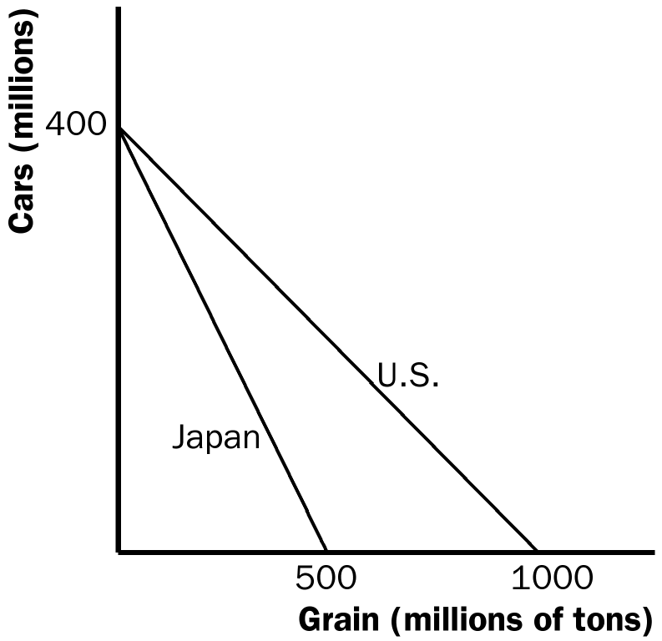

Figure 3

c. Because a U.S. worker produces either 4 cars or 10 tons of grain, the opportunity cost of one car is 2 1/2 tons of grain, which is 10/4. Similarly, the U.S. opportunity cost of a ton of grain is 2/5 car (4 divided by 10). Because a Japanese worker produces either 4 cars or 5 tons of grain, the opportunity cost of one car is 1 1/4 tons of grain, which is 5/4 and the Japanese opportunity cost of a ton of grain is 4/5 car. This results in the following table:

 | Opportunity Cost of:
 | One Car (in terms of tons of grain given up) | One Ton of Grain (in terms of cars given up)
U.S. | 2 1/2 | 2/5
Japan | 1 1/4 | 4/5

d. Neither country has an absolute advantage in producing cars, because they are equally productive (the same output per worker); the United States has an absolute advantage in producing grain, because it is more productive (greater output per worker).

e. Japan has a comparative advantage in producing cars, because it has a lower opportunity cost in terms of grain given up. The United States has a comparative advantage in producing grain, because it has a lower opportunity cost in terms of cars given up.

f. With half the workers in each country producing each of the goods, the United States would produce 200 million cars (50 million workers times 4 cars each) and 500 million tons of grain (50 million workers times 10 tons each). Japan would produce 200 million cars (50 million workers times 4 cars each) and 250 million tons of grain (50 million workers times 5 tons each).

g. From any situation with no trade, in which each country is producing some cars and some grain, suppose the United States changed one worker from producing cars to producing grain. That worker would produce 4 fewer cars and 10 additional tons of grain. Then suppose the United States offers to trade 7 tons of grain to Japan for 4 cars. The United States will do this because the cost of producing 4 cars in the United States is 10 tons of grain. By trading, the United States can gain 4 cars for a cost of only 7 tons of grain, so it is better off by 3 tons of grain. Suppose Japan changes one worker from producing grain to producing cars. That worker would produce 4 more cars and 5 fewer tons of grain. Japan will take the trade because it values 4 cars at 5 tons of grain, so it will be better off by 2 tons of grain. With the trade and the change of one worker in both the United States and Japan, each country gets the same amount of cars as before and both get additional tons of grain (3 for the United States and 2 for Japan). Thus, by trading and changing their production, both countries are better off.

3. a. Pat's opportunity cost of making a pizza is 1/2 gallon of root beer, because she could brew 1/2 gallon in the time (2 hours) it takes her to make a pizza. Kris's opportunity cost of making a pizza is 2/3 gallon of root beer, because she could brew 2/3 of a gallon in the time (4 hours) it takes her to make a pizza. Pat has an absolute advantage in making pizza because she can make one in 2 hours, while it takes Kris 4 hours. Because Pat's opportunity cost of making pizza is less than Kris', Pat has a comparative advantage in making pizza.

b. Because Pat has a comparative advantage in making pizza, she will make pizza and exchange it for root beer that Kris makes.

c. The highest price of pizza in terms of root beer that will make both roommates better off is 2/3 of a gallon of root beer. If the price were higher than that, then Kris would prefer making her own pizza (at an opportunity cost of 2/3 of a gallon of root beer) rather than trading for pizza that Pat makes. The lowest price of pizza in terms of root beer that will make both roommates better off is 1/2 gallon of root beer. If the price were lower than that, then Pat would prefer making her own root beer (she can make 1/2 gallon of root beer instead of making a pizza) rather than trading for root beer that Kris makes.

4. a. Because a Canadian worker can make either 2 cars a year or 30 bushels of wheat, the opportunity cost of a car is 15 bushels of wheat. Similarly, the opportunity cost of a bushel of wheat is 1/15 of a car. The opportunity costs are the reciprocals of each other.

b. See Figure 4. If all 10 million workers produce 2 cars each, they produce a total of 20 million cars, which is the vertical intercept of the production possibilities frontier. If all 10 million workers produce 30 bushels of wheat each, they produce a total of 300 million bushels, which is the horizontal intercept of the production possibilities frontier. Because the trade-off between cars and wheat is always the same, the production possibilities frontier is a straight line.

If Canada chooses to consume 10 million cars, it will need 5 million workers devoted to car production. That leaves 5 million workers to produce wheat, who will produce a total of 150 million bushels (5 million workers times 30 bushels per worker). This is shown as point A on Figure 4.

c. If the United States buys 10 million cars from Canada and Canada continues to consume 10 million cars, then Canada will need to produce a total of 20 million cars. So Canada will be producing at the vertical intercept of the production possibilities frontier. However, if Canada gets 20 bushels of wheat per car, it will be able to consume 200 million bushels of wheat, along with the 10 million cars. This is shown as point B in the figure. Canada should accept the deal because it gets the same number of cars and 50 million more bushes of wheat.

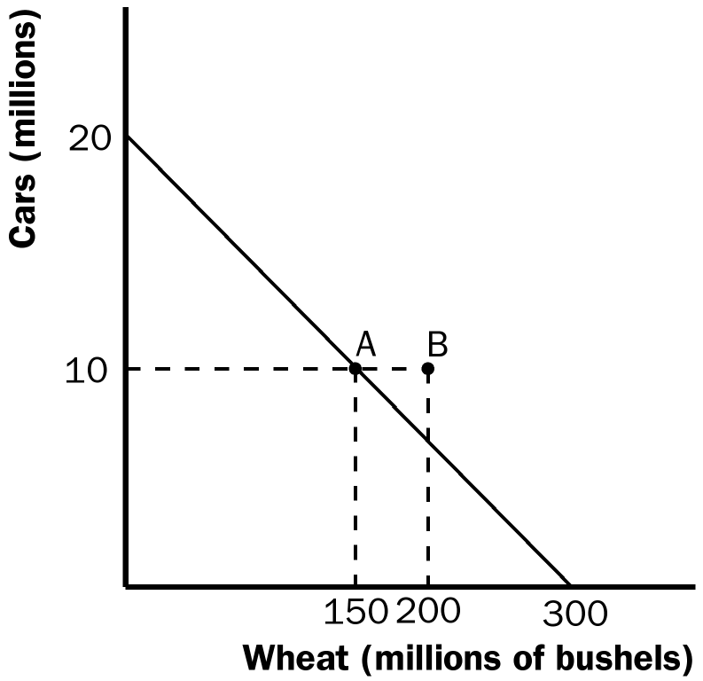

Figure 4

5. a. English workers have an absolute advantage over Scottish workers in producing scones, because English workers produce more scones per hour (50 vs. 40). Scottish workers have an absolute advantage over English workers in producing sweaters, because Scottish workers produce more sweaters per hour (2 vs. 1). Comparative advantage runs the same way. English workers, who have an opportunity cost of 1/50 sweater per scone (1 sweater per hour divided by 50 scones per hour), have a comparative advantage in scone production over Scottish workers, who have an opportunity cost of 1/20 sweater per scone (2 sweaters per hour divided by 40 scones per hour). Scottish workers, who have an opportunity cost of 20 scones per sweater (40 scones per hour divided by 2 sweaters per hour), have a comparative advantage in sweater production over English workers, who have an opportunity cost of 50 scones per sweater (50 scones per hour divided by 1 sweater per hour).

b. If England and Scotland decide to trade, Scotland will produce sweaters and trade them for scones produced in England. A trade with a price between 20 and 50 scones per sweater will benefit both countries, as they will be getting the traded good at a lower price than their opportunity cost of producing the good in their own countries.

c. Even if a Scottish worker produced just one sweater per hour, the countries would still gain from trade, because Scotland would still have a comparative advantage in producing sweaters. Its opportunity cost for sweaters would be higher than before (40 scones per sweater, instead of 20 scones per sweater before). But there are still gains from trade because England has a higher opportunity cost (50 scones per sweater).

6. a. With no trade, 1 pair of white socks trades for 1 pair of red socks in Boston, because productivity is the same for the two types of socks. The price in Chicago is 2 pairs of red socks per 1 pair of white socks.

b. Boston has an absolute advantage in the production of both types of socks, because a worker in Boston produces more (3 pairs of socks per hour) than a worker in Chicago (2 pairs of red socks per hour or 1 pair of white socks per hour).

Chicago has a comparative advantage in producing red socks, because the opportunity cost of producing a pair of red socks in Chicago is 1/2 pair of white socks, while the opportunity cost of producing a pair of red socks in Boston is 1 pair of white socks. Boston has a comparative advantage in producing white socks, because the opportunity cost of producing a pair of white socks in Boston is 1 pair of red socks, while the opportunity cost of producing a pair of white socks in Chicago is 2 pairs of red socks.

c. If they trade socks, Boston will produce white socks for export, because it has the comparative advantage in white socks, while Chicago produces red socks for export, which is Chicago's comparative advantage.

d. Trade can occur at any price between 1 and 2 pairs of red socks per pair of white socks. At a price lower than 1 pair of red socks per pair of white socks, Boston will choose to produce its own red socks (at a cost of 1 pair of red socks per pair of white socks) instead of buying them from Chicago. At a price higher than 2 pairs of red socks per pair of white socks, Chicago will choose to produce its own white socks (at a cost of 2 pairs of red socks per pair of white socks) instead of buying them from Boston.

7. a. Gains from trade will be possible when X does not equal 3. Gains from trade are possible when a comparative advantage exists. The opportunity cost of 1 car in Germany is 200 cases of wine (400 hours/2 hours per case of wine). Likewise, the opportunity cost of 1 case of wine in Germany is 1/200 car. When X=3, the opportunity cost of 1 car in France is 200 cases of wine (600 hours/3 hours per case of wine). In this instance, neither country has a comparative advantage. At all other values of X, a comparative advantage will exist.

b. Germany will export cars and import wine for all values of X<3. For Germany to export cars, it must have the comparative advantage in producing cars and France must have the comparative advantage in producing wine. This occurs when Germany has a smaller opportunity cost of producing cars than France does. We know the opportunity cost of 1 car in Germany is 200 cases of wine. When X<3, the opportunity cost of 1 car in France is greater than 200 cases of wine. For example, when X=2, the opportunity cost of 1 car in France is 300 cases of wine (600 hours/2 hours per case = 300 cases). Therefore, Germany will have the comparative advantage in cars, export cars and import wine for all values of X<3.

8. a. The production possibilities frontiers for the two countries are shown in Figure 5. If, without trade, a U.S. worker spends half of his time producing each good, the United States will have 50 shirts and 10 computers. If, without trade, a worker in China spends half of his time producing each good, China will have 50 shirts and 5 computers.

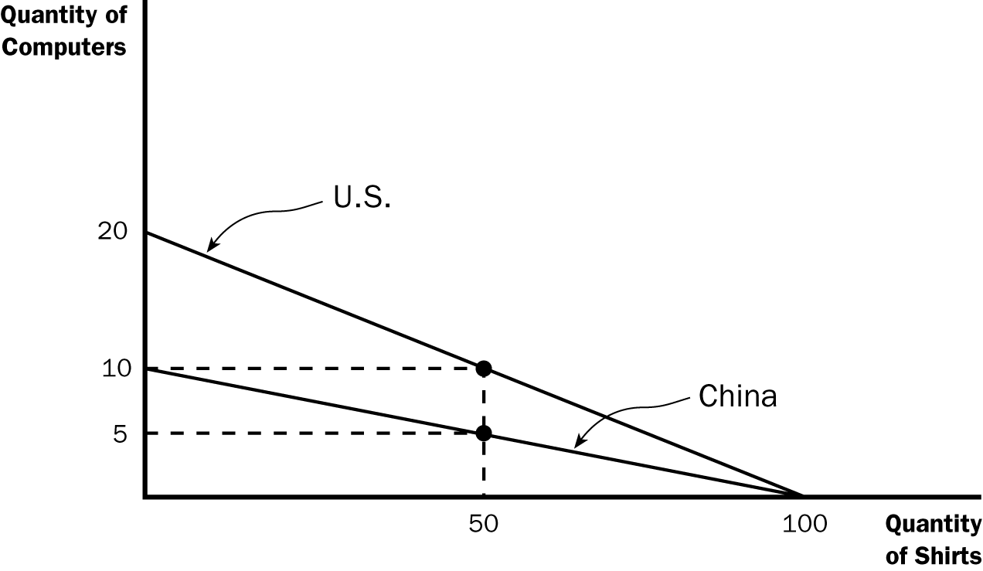
Figure 5

b. China would export shirts because it has the lower opportunity cost of shirts. For China, the opportunity cost of 1 shirt is 1/10 computer. For the United States, the opportunity cost of a shirt is 1/5 computer. Therefore, China has a comparative advantage in the production of shirts and the United States has a comparative advantage in the production of computers.

The price of a shirt will fall between 1/5 and 1/10 of a computer. An example would be a price of 1/7 computer. Suppose China produced only shirts (100 shirts) and exported 50 shirts in exchange for 7.14 computers (50/7 = 7.14). This trade makes China better off than it was before trade (50 shirts and 5 computers). The United States would also benefit from this trade. If the United States produced only computers (20 computers), and traded 7.14 of them to China for 50 shirts, the United States would have 12.86 (20-7.14) computers and 50 shirts and would be better off than before trade (10 computers and 50 shirts).

c. The price of a computer would fall between 5 and 10 shirts. If the price were below 5, the United States would not be willing to export computers because the opportunity cost of a shirt for the United States is 1/5 computer. If the price were greater than 10 shirts, China would not be willing to import computers because (for China) the opportunity cost of a computer is 10 shirts.

d. Once the productivity is the same in the two countries, the benefits of trade disappear. Trade is beneficial because it allows countries to exploit their comparative advantage. If China and the United States have exactly the same opportunity cost of producing shirts and computers, there will be no more gains from trade available.

9. a. True; two countries can achieve gains from trade even if one of the countries has an absolute advantage in the production of all goods. All that is necessary is that each country has a comparative advantage in some good.

b. False; no one can have a comparative advantage in everything. Comparative advantage reflects the opportunity cost of one good or activity in terms of another. If you have a comparative advantage in one thing, you must have a comparative disadvantage in the other thing.

c. False; trades can and do benefit both sides⎯especially trades based on comparative advantage. If both sides did not benefit, trades would never occur.

d. False; to be good for both parties, the trade price must lie between the two opportunity costs.

e. False; trade that makes the country better off can harm certain individuals in the country. For example, suppose a country has a comparative advantage in producing wheat and a comparative disadvantage in producing cars. Exporting wheat and importing cars will benefit the nation as a whole, as it will be able to consume more of both goods. However, the introduction of trade will likely be harmful to domestic auto workers and manufacturers.

